Users must download VeraCrypt in order to Proceed.

Step 1) First you need to create an encrypted container. Open VeraCrypt and create a volume. Select encrypted container (the default). Make it a standard container. Select a directory to put it in and give it a name you will remember.

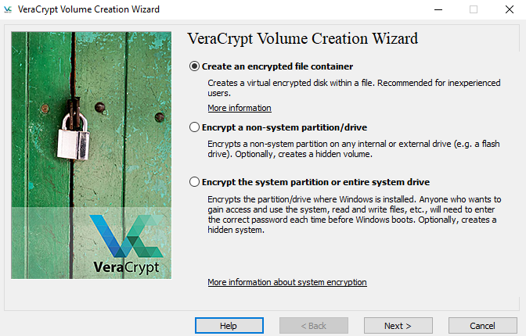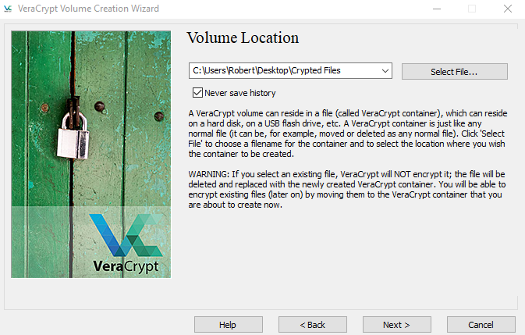

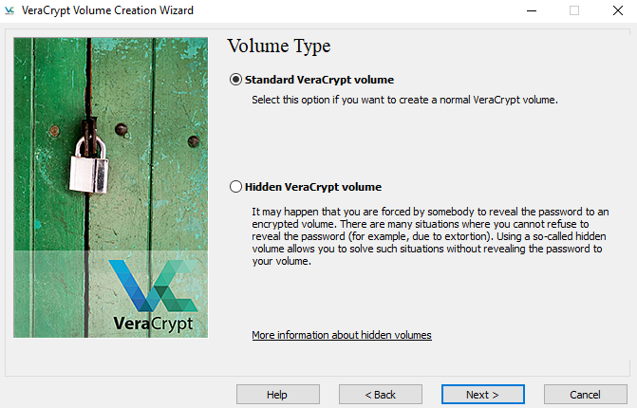

Step 2) Use the default encryption and give it a size of 20 Meg. Put in a simple password that you will remember (even though it will complain about a simple password). Go ahead and format the container. 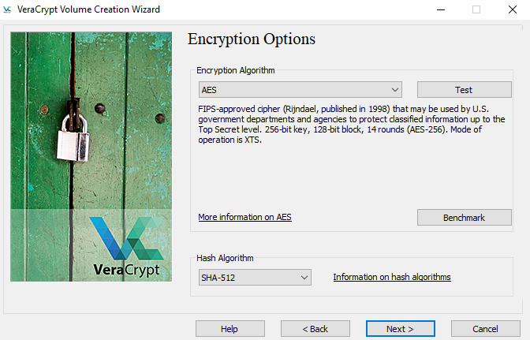

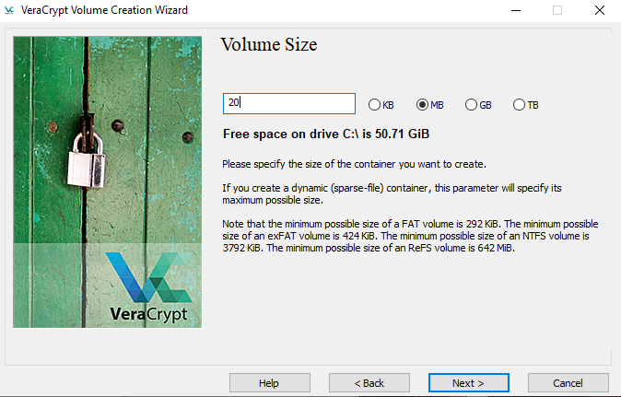

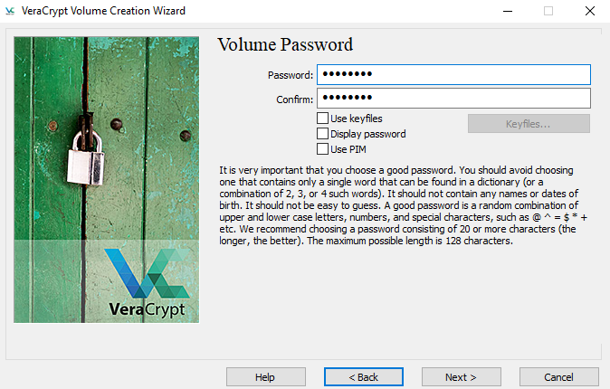

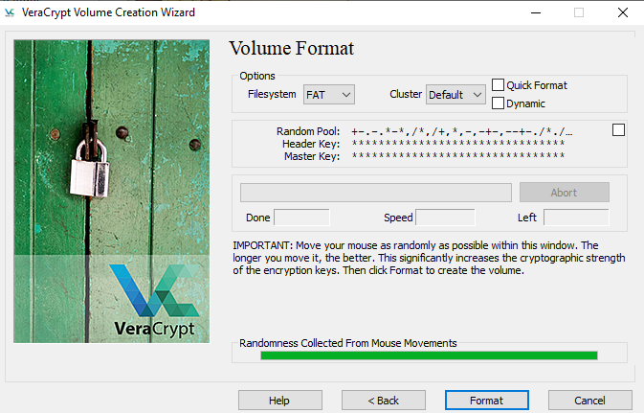

Step 3) Next you have to mount the container. Select an unused letter for the container, select the file and mount.

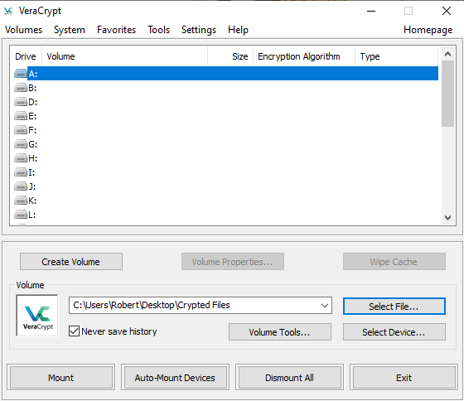

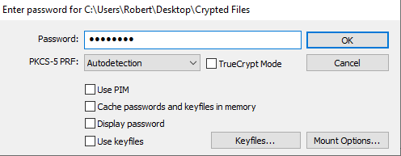

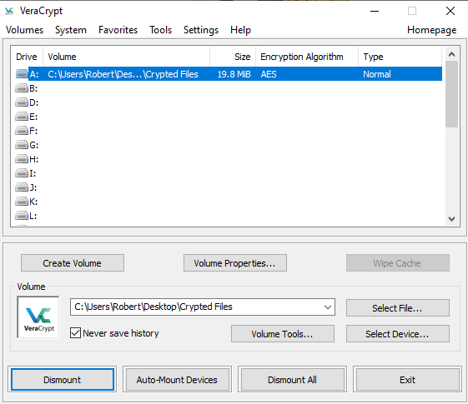

Step 4) Create some files and put them in the container.

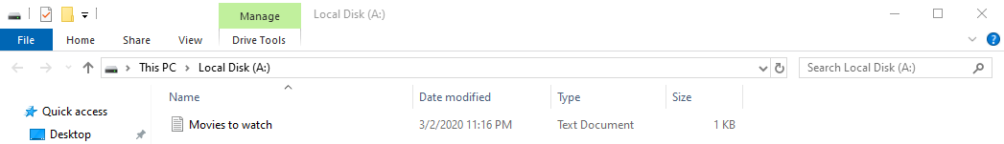

Step 5) Dismount the container and look at the file in File Explorer. Include in the lab report the name of the file and the size.

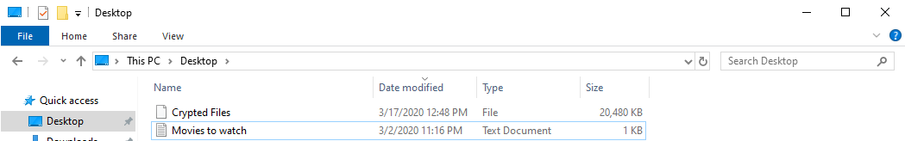

**For the last part of the lab report, list some of the data that falls under the Massachusetts PII law and what a business’s obligation are under the law. Include the date the law went into effect.**

* Social Security Number
* Driver’s License Number
* State Identification Card Number
* Financial Account Number, credit or debit card number

On March 1, 2010 the data protection and privacy law in the United States – 201 C.M.R. 17: Standards for the Protection of Personal Information of Residents of the Commonwealth or “The Massachusetts Standards”, acted. In accordance with the Massachusetts General Law Chapter 93H Requires Business Regulation and Consumer Affairs that licenses or owns personal information of Massachusetts residents to comply with the minimum-security standards set forth in the regulation.

The Massachusetts Standards require any person or entity that owns or licenses personal information of a Massachusetts resident to implement a written information security program (“WISP”) with appropriate administrative, technical, and physical safeguards.